**Build a Workflow from Scratch with SAP Cloud Platform Workflow Management**DEV163

Exercise 3 | Process Visibility   
Archana Shukla / SAP

Table of ContentS

[Overview 3](#_Toc52668184)

[Create a Business Scenario 4](#_Toc52668185)

[Change Context Variable Data Types 6](#_Toc52668186)

[Enhance business scenario with phases 8](#_Toc52668187)

[Create calculated attributes 11](#_Toc52668188)

[Create Process performance indicators 16](#_Toc52668189)

[Configure and monitor Process Visibility scenarios 33](#_Toc52668190)

[Access the SAP Cloud Platform Process Visibility Workspace 37](#_Toc52668191)

[Summary 43](#_Toc52668192)

# Overview

Estimated time: 60 minutes   
  
Process Visibility service offers the capabilities to monitor and track the business processes and key business KPIs in real-time so that the business users can identify real time operational inconsistencies of the ongoing process that helps them to take better tactical day-to-day decisions. In this exercise, you will create the visibility scenario to track capital expenditure approval process and learn how it helps to get the real-time insights into the operational progress and business KPIs using customized workspace.

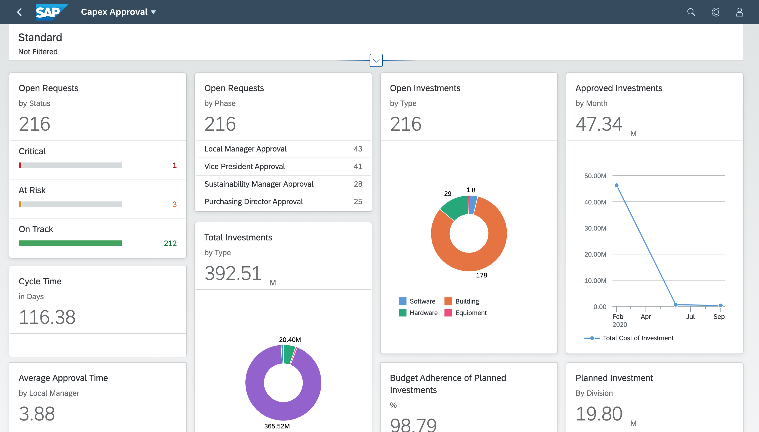

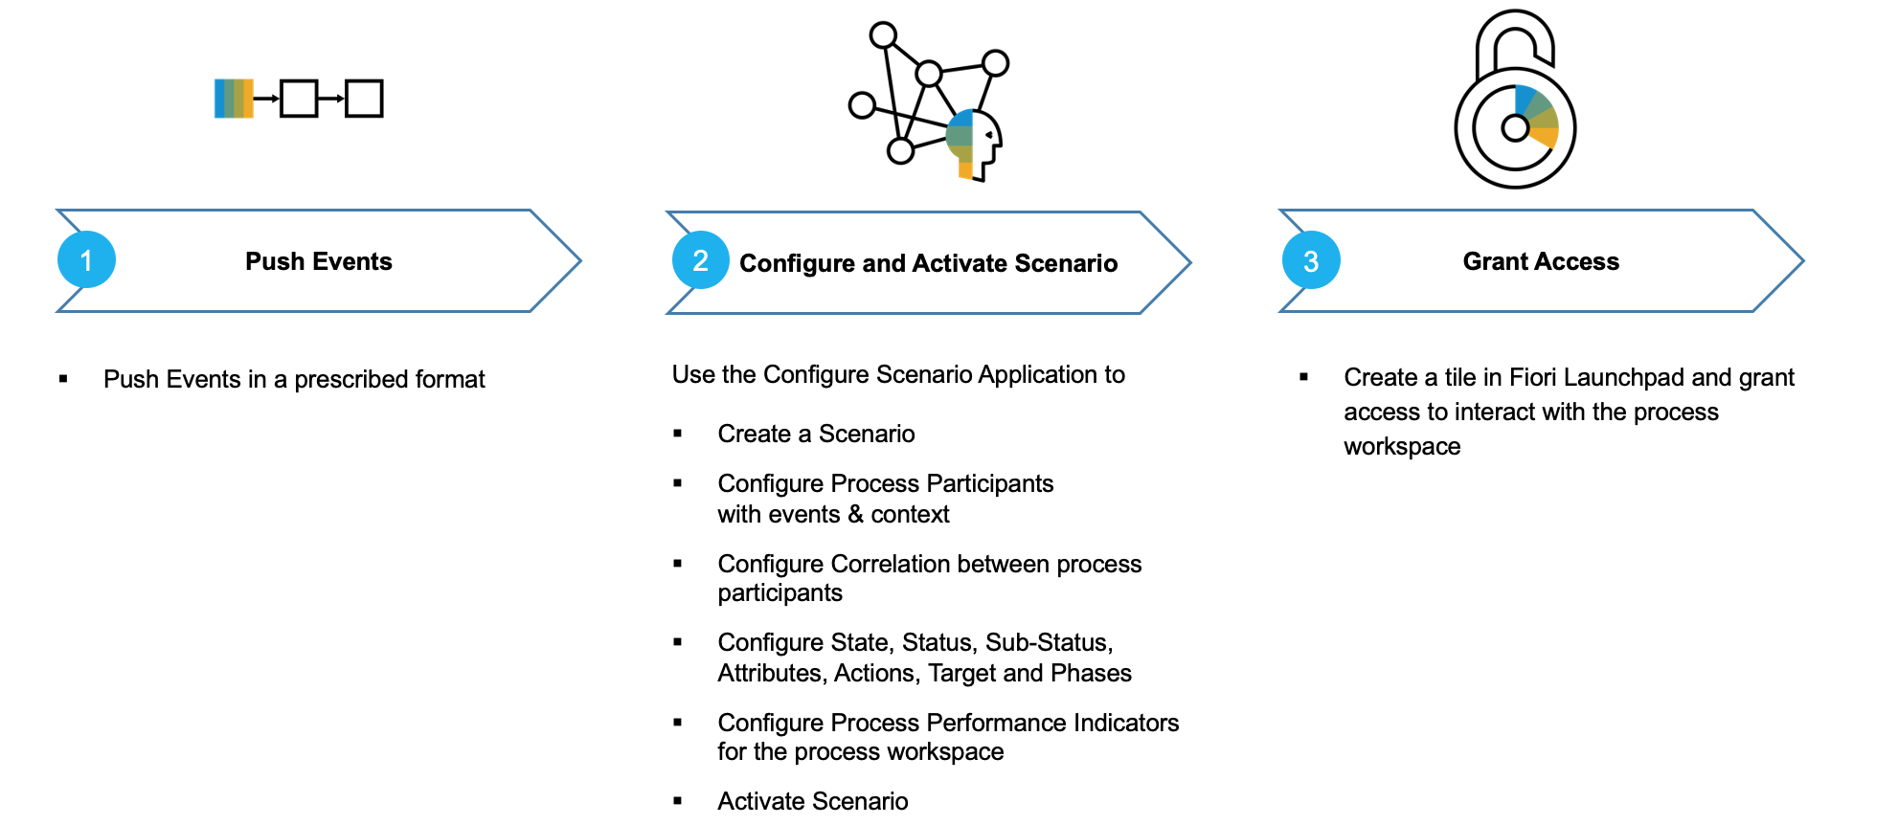

In this exercise, you will learn how to:

1. *Configure & Activate a business scenario.*
2. *Define correlation between process participants.*
3. *Configure phases and process performance indicators.*
4. *View events that have been acquired by process visibility service.*
5. *Process acquired events.*
6. *Access process workspace to track end to end process in real-time.*

# Create a Business Scenario

| Explanation | Screenshot |
| --- | --- |
| If you have not executed Exercise 1 and are coming directly to execute this Exercise then you have to import and deploy the workflow. Follow the Appendix |  |
| 1. Open **Workflow Management Launchpad** using your trial username and password. 2. Click to open Create Visibility Scenarios. |  |
| 1. Click fieldicon to add a new Visibility Scenario |  |
|
| Provide the following details:   | Name | **CAPEX\_00** | | --- | --- | | ID | **CAPEX\_00** | | Description | Capital Expenditure Business Scenario |  1. Click fieldicon. | imb__559 |
| 1. The new business scenario will be created.   Note: The **Status** is in **'Draft'** status.  Note: You can search for the business scenario you created using the search box.   1. Click fieldicon_12 to open the newly created business scenario |  |
| 1. To add workflow as a participant, click fieldicon. 2. Click |  |
| 1. All SAP Cloud Platform Workflows deployed in your tenant will be shown. Type the name of the workflow you created and click fieldicon_6 to search. | imb__562 |
| 1. Click fieldicon. | imb__563 |

# Change Context Variable Data Types

| Explanation | Screenshot |
| --- | --- |
| Note: By default, the context variables from the workflow will be of type 'String'.We will now change the data-type of few context attributes in order to use them in the performance indicators.   1. Select the attribute **'ROI'** and click fieldicon. | imb__564 |
| 1. Click fieldicondrop down for the **Data Type****.** 2. Select **Double** from the drop down. 3. Click fieldicon. | imb__565  imb__566 |
|
| 1. Similarly, select the context variable **CAPEX** and set the **Data Type** to **Double**. | imb__567 |
| 1. Finally select the context variable with name **Total Cost** and set the **Data Type** to **Double.** | imb__568 |
| 1. Click fieldicon | imb__569 |

# Enhance business scenario with phases

| Explanation | Screenshot |
| --- | --- |
| You can define phases for your Business Scenario. Phases usually are a Business-Friendly aggregated view of activities and steps in the process. An event(s) marks the start of the phase and a set of subsequent events can mark the end of it.   1. Click the  tab |  |
| 1. Click   to add a new phase   Provide the following information   | Name | Local Manager Approval | | --- | --- | | ID | Local\_Manager\_Approval |  1. Click . |  |
|
| 1. Click the dropdown buttonfor **Start Events****.** 2. Click Approval Task (Local Manager) Created. |  |
| 1. Click the dropdown buttonfor **End Events****.** 2. Click Approval Task (Local Manager) Completed. |  |
| 1. Click . to create another phase |  |
| Provide the following information   | Name | Central Manager Approval | | --- | --- | | ID | Central\_Manager\_Approval |  1. Click . |  |
| 1. Click the dropdown button for **Start Events****.** 2. Click Approval Task (Central Manager) Created. |  |
| 1. Click the dropdown buttonfor **End Events****.** 2. Click Approval Task (Central Manager) Completed. |  |
| 1. Click Save . |  |

# Create calculated attributes

| Explanation | Screenshot |
| --- | --- |
| A business scenario has 4 type of attributes (a) Default, (b) Context, (c) Step and (d) Calculated.  In this section you will create calculated attributes based on aggregation and expression types. These calculated attributes will act as a Measure while configuring Process Performance Indicators.   1. Click Attributes . |  |
| 1. Click  to add new attributes   Provide the following details  **Name**:  Month  **ID**: <this will automatically be created as>  Month  **Expression Type**:  Month of Attribute  **Attribute**:  Start Time   1. Click . |  |
|
| 1. Repeat the steps and create the following attributes   **Name**:  Number of Reworks requested  **ID**: <this will automatically be created as>  Number\_of\_Reworks\_requested  **Expression Type**:  Has event occurred  **Event**:  Rework Task Created   1. Click . |  |
| 1. Add another attribute with the following details   **Name**:  Pending Local Manager Approvals  **ID**: <this will automatically be created as>  Pending\_Local\_Manager\_Approvals  **Expression Type**:  Event A occurred and not Event B  **Event A**:  Approval Task (Local Manager) Created  **Event B**:  Approval Task (Local Manager) Completed   1. Click . |  |
| 1. Add the following attribute   **Name**:  Pending Central Manager Approvals  **ID**: <this will automatically be created as>  Pending\_Central\_Manager\_Approvals  **Expression Type**:  Event A occurred and not Event B  **Event A**:  Approval Task (Central Manager) Created  **Event B**:  Approval Task (Central Manager) Completed   1. Click . |  |
| 1. Add the following attribute   **Name**:  Average Approval Time from Local Manager  **ID**: <this will automatically be created as>  Average\_Approval\_Time\_from\_Local\_Manager  **Expression Type**:  Duration between events  **Event A**:  Approval Task (Local Manager) Created  **Event B**:  Approval Task (Local Manager) Completed   1. Click . |  |
| By default, the **Unit** is set to **Days**. Now, change it to hours or minutes to have a quicker calculation in this exercise.   1. Click  to open the **Unit** dropdown. 2. Click . |  |
| 1. Add the following attribute   **Name**:  Average Approval Time from Central Manager  **ID:** <this will automatically be created as> Average\_Approval\_Time\_from\_Central\_Manager  **Expression Type**:  Duration between events  **Event A:**  Approval Task (Central Manager) Created  **Event B**:  Approval Task (Central Manager) Completed   1. Click. |  |
| 1. By default, the **Unit** is set to **Days**. Change it to hours or minutes to have a quicker calculation in this exercise. 2. Click  to open the **Unit** dropdown. 3. Click . |  |
| You have now created all the attributes that will be used to create process performance indicators for the capital expenditure approval process. |  |
| 1. Click. |  |

# Create Process performance indicators

| Explanation | Screenshot |
| --- | --- |
| Performance indicators represent aggregated information of a measure, grouped by dimensions and applied filters. A group of performance indicators gives the business users a holistic view of the process and enables them to understand process performance at a glance.  There will be the commonly used process performance indicators created by-default when you create the business scenario.   1. Click  tab |  |
| You will now rename the default process performance indicators.   1. Select **Open Instances** and click  to rename. 2. In the pop-up, change the **Title** as **Pending CAPEX Approvals**. 3. Click . |  |
|
| 1. Now, select the 2nd indicator named **Completed Instances**. 2. Click . |  |
| 1. In the pop-up, change the **Title** as **Completed CAPEX Approvals**. 2. Click . |  |
| 1. Now, select the 3rd indicator named **Cycle Time in Days.** |  |
| 1. Click . |  |
| 1. In the pop-up, change the **Title** as **CAPEX Approval Cycle Time**. 2. Click . |  |
| 1. Now, select the 4th indicator named **Suspended Instances.** 2. Click . |  |
| 1. In the pop-up, change the **Title** as **Suspended CAPEX Approvals**. 2. Click . |  |
| 1. Now, select the 5th default indicator named **Cancelled Instances.** 2. Click . |  |
| 1. In the pop-up, change the **Title** as **Cancelled CAPEX Approval Requests**. 2. Click . |  |
| 1. Now, select the 6th and final default indicator named **Failed Instances**. 2. Click . |  |
| 1. In the pop-up, change the **Title** as **Failed CAPEX Approval Requests**. 2. Click . |  |
| Let's now create some custom Performance Indicators. Each process performance indicator are shown as a tile in Process Workspace.   1. Click  to add a process performance indicator which will show the details of **Open Capex Requests**, distributed by phase and filtered by the **State** of the process. |  |
| Provide the following details:     | Title | Open Requests | | --- | --- | | Sub-Title | by Phase | | ID | Open\_Requests |        1. Click . |  |
| 1. Click the dropdown button from the **Representation.** 2. Click the **List** type. |  |
| 1. From the **Measures** dropdown, select **Number of Instances**. |  |
| 1. From the **Dimensions** dropdown, select **Active Phases**. |  |
| 1. Click  to add a filter |  |
| Provide the following details:   | Attribute | State | | --- | --- | | Operator | equal to | | Value | Open |        1. Click . |  |
| Similarly, create 2nd custom process performance indicator to show *Total Investments* distributed across *Type of Investments* in a Donut Chart.   1. Click  to add a new Performance Indicator. |  |
| Provide the following detals:     | Title | Total Investments | | --- | --- | | Sub-Title |  | | ID | Total\_Investments |        1. Click . |  |
| 1. Select **Donut Chart** from the **Representation** dropdown. |  |
| 1. Select **Total Cost of Investment** from the **Measure** dropdown. |  |
| 1. Select **Type** from the **Dimension** dropdown. |  |
| Rework in an approval process lead to delays and increases overall operational cost. So we create 3rd custom process performance indicator to track *Number of Rework Requests* in a Header Chart.   1. Click  to add another Performance Indicator. |  |
| Provide the following details     | Title | Number of Rework Requests | | --- | --- | | Sub-Title |  | | ID | Number\_of\_Rework\_Requests |        1. Click . |  |
| 1. Select **Number of Reworks** requested from the **Attribute** dropdown. |  |
| Similarly, create 4th and 5th custom process performance indicator to track overalltime taken to approve the capital investment request in form of *Average Approval Time* by Local & Central Managers displayed as the *Header* chart.  In any process, the overall time it takes to complete the process is always a key performance metrics as it indicates any bottlenecks in the process in real-time and helps business user to take appropriate actions to unblock the business process.     1. Click  to create a Performance Indicator. |  |
| Provide the following details:   | Title | Average Approval Time | | --- | --- | | Sub-Title | by Local Manager | | ID | Average\_Approval\_Time\_By\_LM |        1. Click . |  |
| 1. Select **Average Approval Time for Local Manager** from the **Measure** dropdown. |  |
| Similarly**,** create another *Average Approval Time* performance indicator for *Central Manager* with the following details:   | Title | Average Approval Time | | --- | --- | | Sub-Title | by Central Manager | | ID | Average\_Approval\_Time\_CM |        1. Click . |  |
| 1. Select **Average Approval Time for Central Manager** from the **Measure** dropdown. |  |
| Now create 6th custom process performance indicator to track the *total amount of the capital expenditure requests* have been raised over past months shown as *Line Chart*.  Enter the following details:   | Title | Capital Expenditure | | --- | --- | | Sub-Title | per Month | | ID | Capital\_Expenditure |        1. Click . |  |
| 1. Select **Line Chart** from the **Representation** dropdown. |  |
| 1. Select the **Measure** as **CAPEX** and **Dimension** as **Month** from the respective dropdowns. |  |
| Now create 7th custom process performance indicator to track the *return of investment* over past months shown as *List Chart*.  Enter the following details:   | Title | ROI | | --- | --- | | Sub-Title | per Month | | ID | ROI |        1. Click . |  |
| 1. Select **ROI** as the **Measure** and **Month** as the **Dimension** from the respective dropdowns. |  |
| 1. Click **Save**. |  |
| Now we have completed configuring all the performance indicators.   1. Click **Activate** to activate the visibility scenario.   Once you activate the visibility scenario, it becomes live and you can start tracking the process from Process Workspace. |  |
| 1. Click  to go back to the **Home Page** of the Worflow Management launchpad. |  |
| 1. Click the **Process Workspace** tile to view all activated visibility scenarios. |  |
| 1. If needed, search for the visibility scenario by entering the name of your visibility scenario in the **Search Box** and click . |  |
| 1. You should see the activated business scenario and click on it to navigate into the dashboard. |  |
| You will notice the Business Scenario dashboard.  Note that it will have no data. The next section will deal with that. |  |

# 

# Configure and monitor Process Visibility scenarios

Once the business scenario is activated, events of the workflow instances started after the business scenario was activated will be auto subscribed. Workflow attributes configured in the workflow model are pushed as context attributes. The following events are pushed from Workflow to Process Visibility service

| Workflow Activity | Event |
| --- | --- |
| Workflow lifecycle events | Started,Completed, Canceled, Suspended |
| User Task | Created,Completed |
| Intermediate message event | Triggered, Reached |

To start the workflow that you have associated with the visibility scenario, follow section **EXECUTE AND MONITOR WORKFLOW** from Exercise 1

| Explanation | Screenshot |
| --- | --- |
| In this unit, you will learn how to view the events acquired by the process visibility. Service. This is more of an Administrative task and therefore need PVTenantAdmin and PVOperator roles to access the application.   1. From the Workflow Management Launchpad Home Page, click on **Event Acquisition** tile. |  |
| Using the **Event Acquisition** application, you can do the following:   * View the events that have been acquired by process visibility. * Monitor errors while consuming the events pushed to the service.  1. Click . |  |
|
|
| 1. Click **Process Definition** in the filter dialog. |  |
| Enter **CAPEX\_00** which refers to the workflow definition id that was imported in your business scenario.     1. Click . |  |
| You should be able to see the events corresponding to the Process Definition ID. |  |
| 1. Click  to go back to the **Home Page** of the Worflow Management launchpad. |  |
| 1. Click **Monitor Scenarios** tile. |  |
| 1. If needed, search for your scenario by providing the scenario name as **CAPEX\_00**. |  |
| Note:   * For a given scenario, processing of events is auto scheduled on scenario activation. The default schedule frequency for processing is **5 minutes**. * Click the refresh button (on top-right corner) to see the fresh processing information. You can see all the events from your scenario definition. * The **Process Data** and **Clear Processed Data** buttons on the footer enable you to manually trigger the processing the data and clearing the processed data respectively. Once you have cleared the processed data, you can click again *Processed Data* to reprocess the subscribed events.  1. Click . |  |
| All processed job information will be shown. |  |

# Access the SAP Cloud Platform Process Visibility Workspace

| Explanation | Screenshot |
| --- | --- |
| 1. Click  to go back to the **Home Page** of the Worflow Management launchpad. |  |
| 1. Navigate to the **Process Workspace** by clicking on the tile. 2. If needed, enter the business scenario name in the search field and click . |  |
|
| 1. Select the Business Scenario by clicking on it. |  |
| You will see the Process Performance Indicator tiles you configured in the dashboard. You can rearrange the tiles in order of preference by dragging-and-dropping them. |  |
| 1. Let us drill down into a process instance. For this,choose to click on any of the PPI you are interested.   For example, to view what CAPEX approval processes are on track, click. . |  |
| All **On Track** CAPEX approval process instances will be listed out. The table will have rows corresponding to the context of the process instance and custom attributes that you configured while creating visibility scenario.   1. Select an instance to further drill down and get more details. |  |
| Here you can see all information corresponding to the process as configured in Default Attributes.   1. Let's now navigate to **Phases**. |  |
| Here you will see a graphical representation of the phases with started and end timestamp. The filled-checkbox indicate that the process is currently running at that phase.    Note: You can also change the representation by clicking  .   1. Let's now view the **Path** of the process instance. |  |
| Path is represented as flow diagram which shows the transition from one activity to another, together with the time taken.    Note: You can also choose the representation by clicking |  |
| For example: A process that has undergone (or pushed to) rework will look like this. |  |
| 1. You can navigate back to the previous pages by clicking on . |  |
| You can filter through the Instances by using the filters based on the context or state/status. For example, if there are multiple countries, you can filter by preference.    Note: You can try this out by creating multiple workflow instances and providing varied details, such as different country, currency etc.   1. For example, let's filter by country . |  |
| 1. Clicking  with no data will bring up the value help. 2. Select the filter as:    . |  |
| 1. Click  to apply the filters |  |
| 1. Click  to search based on the filters |  |
| The filtered list can be viewed. |  |
| As mentioned earlier, you can click on any PPI to view it's details. For example, in case you wish to view all the **CAPEX approvals for Software** click the section in the donut chart. |  |
| All instances pertaining to CAPEX for software expenses will be listed.  Feel free to explore the capabilities by creating new workflow instances and viewing the dashboard in real-time. |  |

# Summary

You have completed the exercise!

You are now able to:

1. Create a new business scenario using **Configure Visibility Scenario** application.
2. Add workflow as a process participant.
3. Configure the business scenario with phases and calculated attributes.
4. Create process performance indicators that help you track your key business KPIs.
5. Use **Event Acquisition** application to view the acquired events.
6. Use **Monitor Scenarios** application to schedule processing of events.
7. Access **Process Workspace** to track your end to end processes and key business KPIs in real-time

# APPendix

## Import and Deploy Sample Workflow

| Explanation | Screenshot |
| --- | --- |
| 1. Download **CapexProjectSample.zip**  project from [GitHub](https://github.com/SAP-samples/cloud-workflow-samples/blob/master/cf-onboarding-sample/resources/cf-onboarding-sample.zip) in your local file system and extract the files. |  |
| 1. Logon to **SAP Cloud Platform Trial Home Page** with your trial username and password. 2. Choose **SAP Business Application Studio**. |  |
| 1. Click on the **Dev Space** to go into the workspace and from **File** menu choose **File |** **Open Workspace.**   Note: If you have no dev space, click the **Create Dev Space** with:   * + **Application Type** as **SAP Fiori.**   + Extension as **Workflow Management**.   Else select **PLAY** 46F1C2F18C37A68E to start the space if you see the status as **STOPPED**. |  |
|
| 1. Drag and drop the extracted **CapexProjectSample** folder in the *Open Workspace* dialog and click **Open**. |  |
| 1. You will see that the **CapexProjectSample** project is imported into your workspace. |  |
| 1. Right-click the **mta.yml** file inside the **CapexProjectSample** folder and choose the **Build MTA** option. |  |
| 1. Once the build is completed successfully, right-click on the build file inside mta\_archives and choose **Deploy MTA Archives**.   Note: The deployment will fail if you have not logged in to the trial account.  Check in the bottom blue bar, if you have already logged in to your trial account. If it does not show **organization-name/space-name** then click on the bar and follow the wizard to login to your trial account. |  |
| 1. A successful deployment message will be shown in the terminal once the deployment has completed successfully. |  |